**Biosensors**

A **biosensor** is an analytical device, used for the detection of an [analyte](http://en.wikipedia.org/wiki/Analyte" \o "Analyte), that combines a biological component with a physicochemical detector.[[1]](http://en.wikipedia.org/wiki/Biosensor#cite_note-1)[[2]](http://en.wikipedia.org/wiki/Biosensor#cite_note-2)

* the *sensitive biological element* (e.g. tissue, microorganisms, organelles, cell receptors, [enzymes](http://en.wikipedia.org/wiki/Enzyme), [antibodies](http://en.wikipedia.org/wiki/Antibody), [nucleic acids](http://en.wikipedia.org/wiki/Nucleic_acid), etc.), a biologically derived material or biomimetic component that interacts (binds or recognizes) the analyte under study. The biologically sensitive elements can also be created by [biological engineering](http://en.wikipedia.org/wiki/Biological_engineering).
* the [*transducer*](http://en.wikipedia.org/wiki/Biotransducer) or the *detector element* (works in a physicochemical way; optical, piezoelectric, electrochemical, etc.) that transforms the signal resulting from the interaction of the analyte with the biological element into another signal (i.e., transduces) that can be more easily measured and quantified;
* biosensor reader device with the associated electronics or signal processors that are primarily responsible for the display of the results in a user-friendly way.[[3]](http://en.wikipedia.org/wiki/Biosensor#cite_note-3)This sometimes accounts for the most expensive part of the sensor device, however it is possible to generate a user friendly display that includes transducer and sensitive element(see [Holographic Sensor](http://en.wikipedia.org/wiki/Holographic_Sensor)). The readers are usually custom-designed and manufactured to suit the different working principles of biosensors. Known manufacturers of biosensor electronic readers include PalmSens, Gwent Biotechnology Systems and Rapid Labs.

**THE ANALYTE**

(What do you want to detect?)

* Molecule

Protein, toxin, peptide, vitamin, sugar, metal ion

**SAMPLE HANDLING**

(How to deliver the Analyte to the Sensitive Region?)

* (Micro) fluidics
* Concentration (increase/decrease)
* Filtration/selection

**DETECTION/RECOGNITION**

(How do you specifically recognise the analyte?)

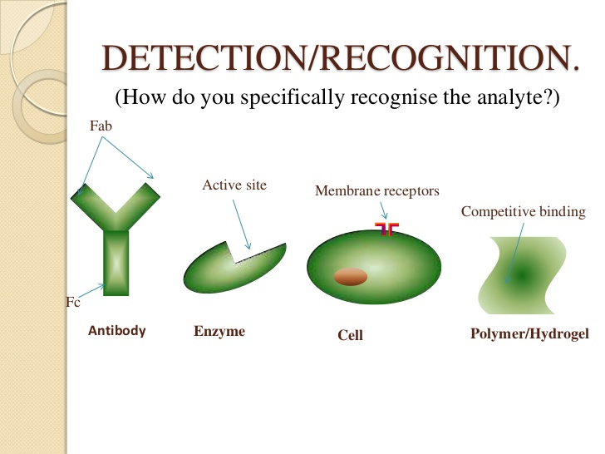

**SIGNAL**

(How do you know there was detection?)

Common Signaling Principles

* Optical (SPR, ELM, IR).
* Electrical (Voltmeter, Potentiometer, Conductivity).
* Electromechanical (QCM).
* Thermal.
* Magnetic.
* Pressure.

**WORKING PRINCIPLE**

1. Analyte diffuses from the solution to the surface of the Biosensor.
2. Analyte reacts specifically & efficiently with the Biological Component of the Biosensor.
3. This reaction changes the physicochemical properties of the Transducer surface.
4. This leads to a change in the optical/electronic properties of the Transducer Surface.
5. The change in the optical/electronic properties is measured/ converted into electrical signal, which is detected.

**TYPES**

* Calorimetric/Thermal Detection Biosensors.
* Optical Biosensors.
* Resonant Biosensors.
* Piezoelectric Biosensors.
* Ion Sensitive Biosensors.
* Electrochemical Biosensors.
  + Conductimetric Sensors.
  + Amperometric Sensors.
  + Potentiometric Sensors.

**PROPERTIES**

A successful biosensor must possess at least some of the following beneficial features:

1. The biocatalyst must be **highly specific** for the purpose of the analyses, be **stable under normal storage conditions** and, except in the case of colorimetric enzyme strips and dipsticks (see later), **show good stability over a large number of assays** (i.e. much greater than 100).
2. The **reaction should be as independent of such physical parameters** as stirring, pH and temperature as is manageable. This would allow the analysis of samples with minimal pre-treatment. If the reaction involves cofactors or coenzymes these should, preferably, also be co-immobilised with the enzyme.
3. The **response should be accurate, precise, reproducible and linear** over the useful analytical range, without dilution or concentration. It should also be free from electrical noise.
4. If the biosensor is to be used for invasive monitoring in clinical situations, **the probe must be tiny and biocompatible, having no toxic or antigenic effects**. If it is to be used in fermenters it should be sterilisable. This is preferably performed by autoclaving but no biosensor enzymes can presently withstand such drastic wet-heat treatment. In either case, the biosensor should not be prone to fouling or proteolysis.
5. The complete biosensor should be **cheap, small, portable and capable of being used by semi-skilled operators.**
6. 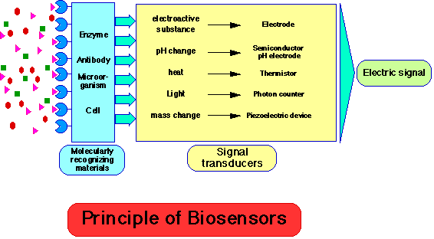There should be a **market for the biosensor**. There is clearly little purpose developing a biosensor if other factors (e.g. government subsidies, the continued employment of skilled analysts, or poor customer perception) encourage the use of traditional methods and discourage the decentralisation of laboratory testing.

**A common example of a commercial biosensor is the**[**blood glucose**](http://en.wikipedia.org/wiki/Blood_glucose)**biosensor, which uses the enzyme**[**glucose oxidase**](http://en.wikipedia.org/wiki/Glucose_oxidase)**to break blood glucose down. In doing so it first oxidizes glucose and uses two electrons to reduce the FAD (a component of the enzyme) to FADH2. This in turn is oxidized by the electrode in a number of steps. The resulting current is a measure of the concentration of glucose. In this case, the electrode is the transducer and the enzyme is the biologically active component.**

Recently, arrays of many different detector molecules have been applied in so called [electronic nose](http://en.wikipedia.org/wiki/Electronic_nose) devices, where the pattern of response from the detectors is used to fingerprint a substance. In the [Wasp Hound](http://en.wikipedia.org/wiki/Wasp_Hound) odor-detector, the mechanical element is a video camera and the biological element is five parasitic wasps who have been conditioned to swarm in response to the presence of a specific chemical. Current commercial electronic noses, however, do not use biological elements.